Appendix 1 – SAS Codes
1.1.1 Descriptive Statistics
proc means data=perm.cosmetics mean std min max n maxdec=2;
var Take1 Take2;
output out=stats_summary mean=Mean std=StdDev min=Min max=Max n=N;
run;
1.1.2 Normality assumption
DATA cosmetics_diff;
SET perm.cosmetics;
Diff = Take1 - Take2;
RUN;
PROC UNIVARIATE DATA=cosmetics_diff NOPRINT;
VAR Diff;
HISTOGRAM Diff / NORMAL;
QQPLOT Diff / NORMAL;
RUN;
1.1.3 Parametric test
PROC TTEST DATA=perm.cosmetics;
PAIRED Take1Take2;
RUN;
1.1.4 Non-Parametric test
data cosmetics;
set perm.cosmetics;
diff = take1 - take2;
run;
proc univariate data=cosmetics mu0=0;
*mu0=0 tests H0: median difference = 0;
var diff; *Analyze the differences;
title 'Wilcoxon Signed-Rank Test for Training Effectiveness';
run;
1.2.1 Multicollinearity check
/* Capture Correlation Matrix and Drop Unnecessary Variables */
ods output PearsonCorr=Corr_Matrix (drop=Var);
proc corr data=perm.pubvalues; /* Suppress printed output */
var Ratevalue Footprint Otherarea House Pubs Food Social Employ Car Garden;
run;
ods output close;

/* Keep only relevant columns */
data Corr_Matrix_Coeff;
set Corr_Matrix;
keep Variable Ratevalue Footprint Otherarea House Pubs Food Social Employ Car Garden;
run;

/* Convert Correlation Matrix to Long Format */
data CorrLong_Coeff;
set Corr_Matrix_Coeff;
array vars[*] Ratevalue Footprint Otherarea House Pubs Food Social Employ Car Garden;
length Variable2 $32;

do i = 1 to dim(vars);
Variable2 = vname(vars[i]);
Correlation = vars[i];
output;
end;

keep Variable Variable2 Correlation;
run;

/* Generate Heatmap for Correlation */
proc sgplot data=CorrLong_Coeff;
heatmap x=Variable y=Variable2 /
colorresponse=Correlation
colormodel=(darkblue white darkred) /* Blue-White-Red gradient */
outline; /* Adds cell borders */

gradlegend / title="Correlation Coefficient"; /* Better legend */

/* Titles and footnotes */
title "Correlation Heatmap";
footnote "Color Legend: Dark Blue = Negative Correlation | White = Neutral | Dark Red = Positive Correlation";

/* Improve Axis Formatting */
xaxis display=(nolabel);
yaxis display=(nolabel);
run;

/* Step 1: Perform Regression Analysis and Output Parameter Estimates */
ods output ParameterEstimates=VIF_table;
proc reg data=perm.pubvalues;
model Value = Ratevalue Footprint Otherarea House Pubs Food Social Employ Car Garden / vif;
run;
ods output close;

/* Step 2: Prepare VIF Data for Visualization */
data VIF_plot;
set VIF_table;
where Variable ^= 'Intercept'; /* Exclude intercept */
keep Variable VarianceInflation;
format VarianceInflation 8.2; /* Round VIF values to two decimal places */

/* Categorize VIF values */
length VIF_Category $15;
select;
when (VarianceInflation <= 5) VIF_Category = "Low";
when (5 < VarianceInflation <= 10) VIF_Category = "Moderate";
otherwise VIF_Category = "High";
end;
run;

/* Step 3: Display VIF Table */
proc print data=VIF_plot label noobs;
label Variable = "Predictor Variable"
VarianceInflation = "VIF Value";
title "Variance Inflation Factor (VIF) Table";
run;

/* Step 4: Create Bar Chart of VIF Values */
proc sgplot data=VIF_plot;
format VarianceInflation 8.2; /* Formats the variable to display with two decimal places */
vbar Variable / response=VarianceInflation
colorresponse=VarianceInflation
colormodel=(green orange red)
datalabel;
xaxis label="Predictor Variables" discreteorder=data;
yaxis label="Variance Inflation Factor (VIF)";
title "VIF Values for Predictor Variables";
run;
1.2.2 Forward Selection Output – Final Model with House and Food & Backward Elimination
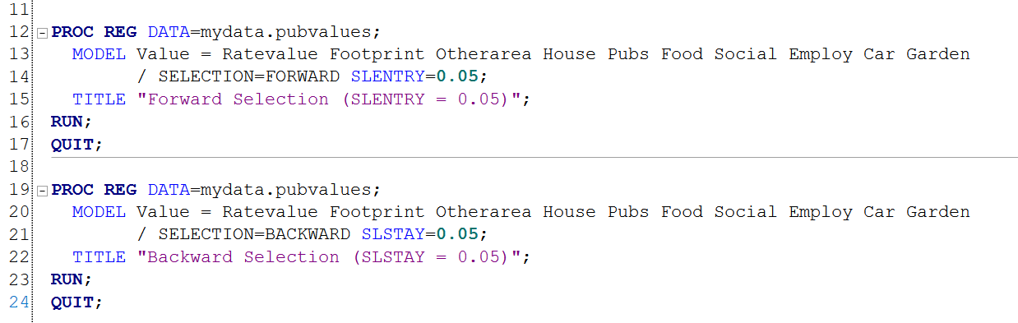
Output – Final Model with Ratevalue, Employ, and Garden
1.2.3 Mallow’s CP Analysis
proc reg data=pubvalues;
model Value = Ratevalue Footprint Otherarea House Pubs Food Social Employ Car Garden /
selection=cp best=10; /* Best 10 models by Cp */
title "Best Subsets Regression Using Mallows’ Cp";
run;
1.2.4 Regression equation coefficients
proc print data=Estimates noobs;

var variable Estimate StdErr tValue Probt;
title "Final Model Coefficients";
run;
1.2.5 Generating Residual and Influence Diagnostics for Final Model
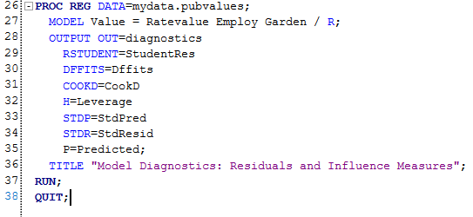

1.2.6 SAS Code for Influence Diagnostics and Output Generation
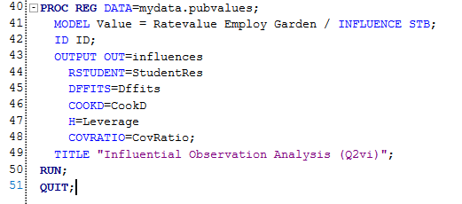
1.2.7 SAS Code to Predict Income for “The Good King James”
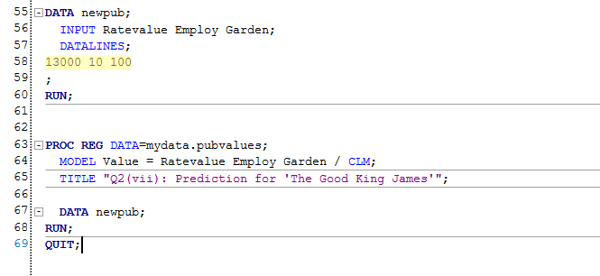
1.3.1 Regression Analysis
proc reg data=travel;
model Claim = Age;
output out=reg1 p=Fitted r=Residual student=StudRes;
title "Regression Analysis: Claim on Age";
run; quit;
1.3.2 Scatterplot with Fitted Regression Line:
proc sgplot data=travel;
scatter x=Age y=Claim;
reg x=Age y=Claim / lineattrs=(color=red thickness=2);
title "Scatterplot of Claim vs. Age with Fitted Regression Line";
run;
1.3.3 Residual Plot (Studentized Residuals vs. Fitted Values)
proc sgplot data=reg1;
scatter x=Fitted y=StudRes;
refline 0 / axis=y lineattrs=(pattern=solid color=red);
title "Studentized Residuals vs. Fitted Values (Claim Model)";
run;

1.3.4
proc reg data=perm.travel plots(only)=(residualplot residualhistogram qqplot);
model LnClaim = Age;
output out=resid_out predicted=pred residual=res student=student_res;
title "Residual Diagnostics for LnClaim ~ Age";
run;
1.3.5 LnClaim vs Fitted line
proc sgplot data=perm.travel;
scatter x=Age y=LnClaim;
reg x=Age y=LnClaim / lineattrs=(color=red thickness=2);
title "LnClaim vs. Age with Fitted Line";
run;
1.3.6 Custom scatterplot of Studentized Residuals vs. Fitted Values
proc sgplot data=resid_out;
scatter x=pred y=student_res / markerattrs=(color=blue);
refline 0 / axis=y lineattrs=(color=red thickness=2);
refline 2 -2 / axis=y lineattrs=(color=gray pattern=2);
title "Studentized Residuals vs. Fitted Values";
xaxis label="Predicted LnClaim";
yaxis label="Studentized Residuals";
run;

1.3.7 Histogram of Studentized Residuals
proc sgplot data=resid_out;
histogram student_res / binwidth=0.5 fillattrs=(color=lightblue);
density student_res / lineattrs=(color=black thickness=2);
title "Distribution of Studentized Residuals";
xaxis label="Studentized Residuals";
run;

1.3.8 Normal Probability Plot (QQ Plot)
proc univariate data=resid_out noprint;
qqplot student_res / normal(mu=est sigma=est);
title "Normal Probability Plot of S
tudentized Residuals";
run;

1.3.9 Predicted Mean Claim for Age=70
proc reg data=travel alpha=0.05;
model LnClaim = Age / clm; /* CLM = Confidence Limits for MEAN */
output out=predicted_values predicted=Pred_LnClaim lclm=Lower_LnClaim uclm=Upper_LnClaim;
title "Log-Linear Model: LnClaim vs. Age";
run;

data final_predictions;
set predicted_values;
Pred_Claim = exp(Pred_LnClaim);
Lower_Claim = exp(Lower_LnClaim);
Upper_Claim = exp(Upper_LnClaim);
run;

proc print data=final_predictions;
where Age = 70;
var Age Pred_Claim Lower_Claim Upper_Claim;
title "Predicted Mean Claim for Age=70";
run;
1.4.1 Create Frequency Table for Late Payments
data Loandata;
input Group Late Count;
datalines;
1 1 53
1 0 247
2 1 34
2 0 266 ;
run;
1.4.2 Calculate Sample Proportions
proc freq data=Loandata;
tables Group*Late /chisq nocol nopercent;
weight Count;
run;

1.4.3 Conduct Hypothesis Test for Proportions
proc freq data=Loandata;
tables Group*Late /riskdiff (equal var = null);
weight Count;
run;

Appendix 2 – Tables and Figures
Table 2.1.1: Descriptive statistics
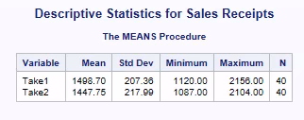
Figure 2.1.2: Normality assessment
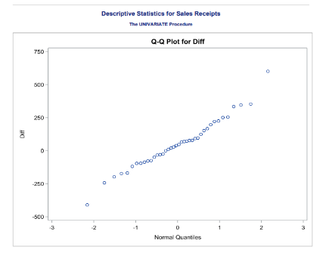
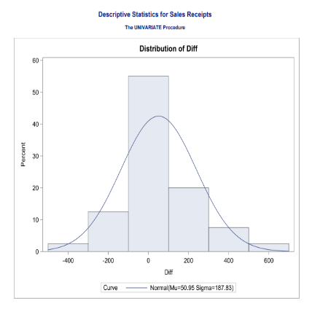
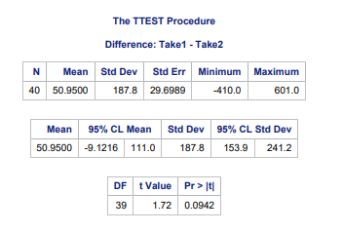
Table 2.1.3: Parametric Test

Q1.4 table

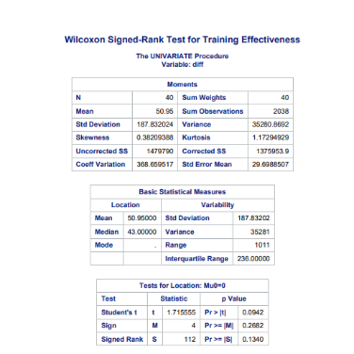
Table 2.1.4: Non Parametric Test

Table 2.2.4
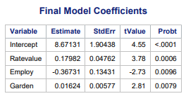
Table 2.2.5
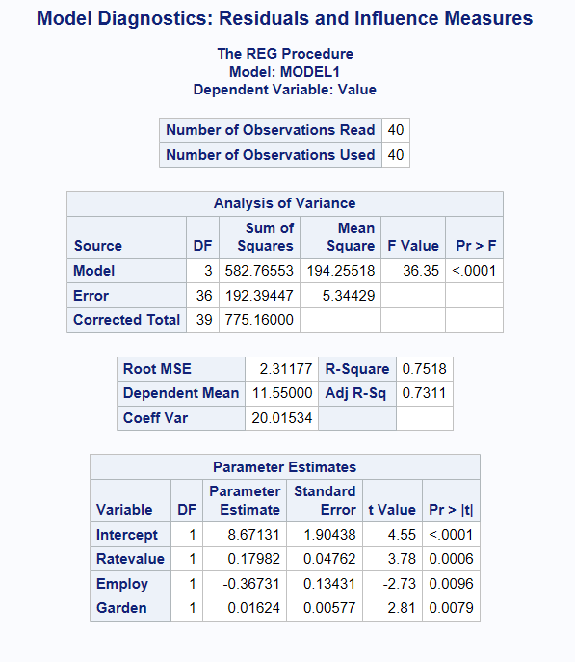
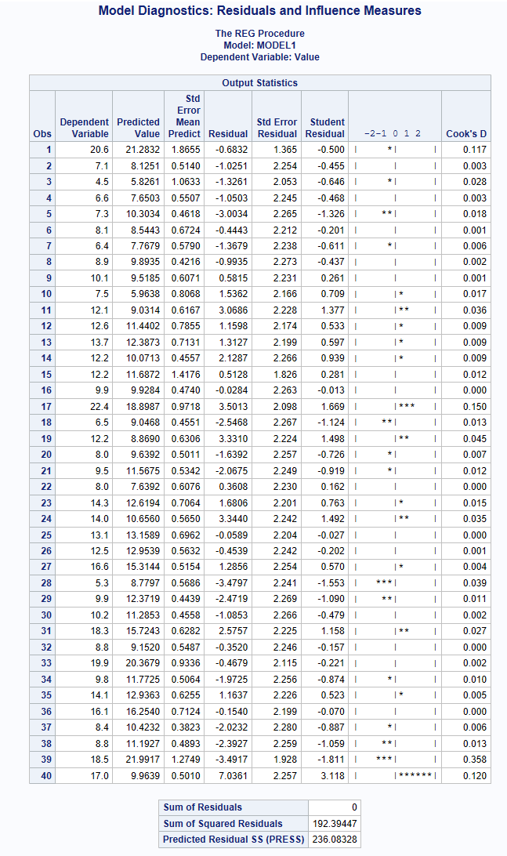
Table 2.1.6
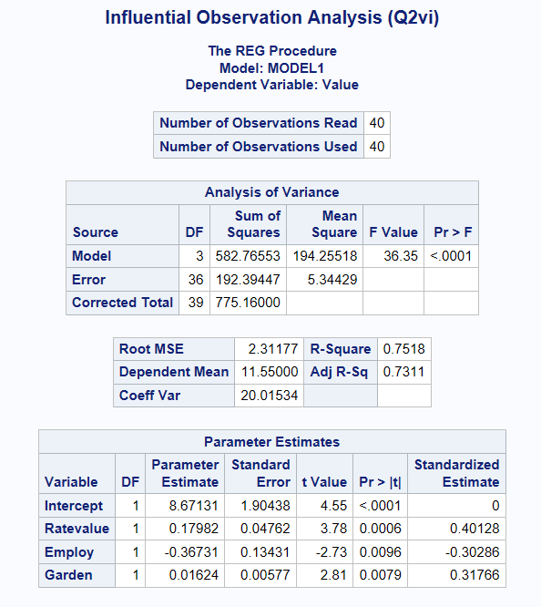
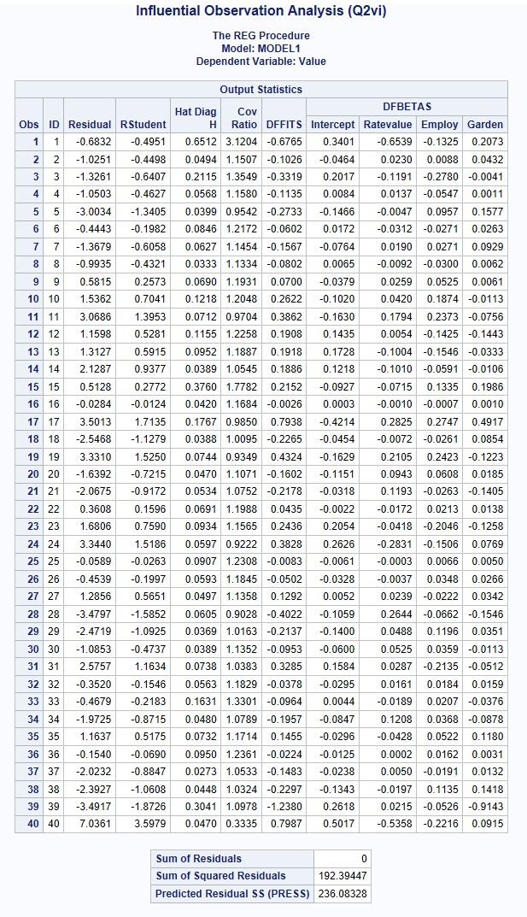
Table 2.1.7
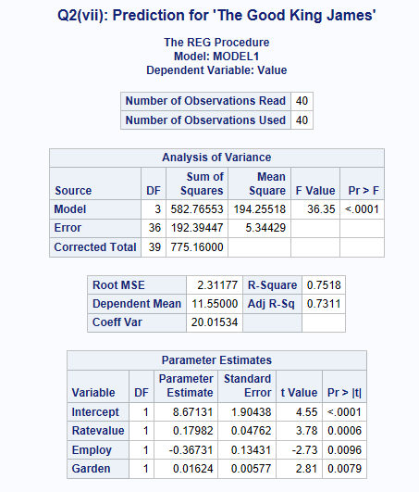
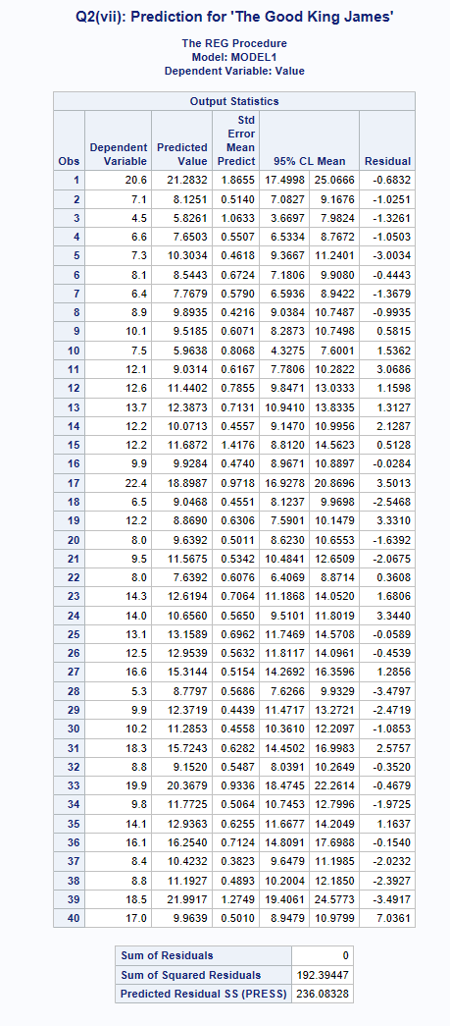

Table 3.1.1
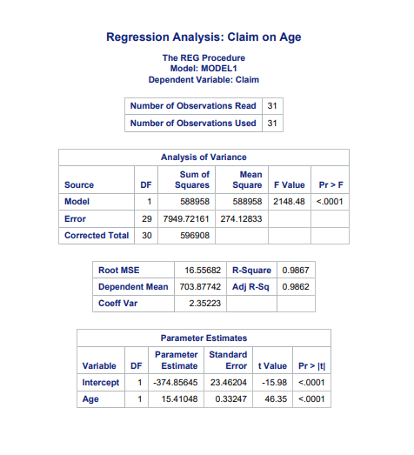

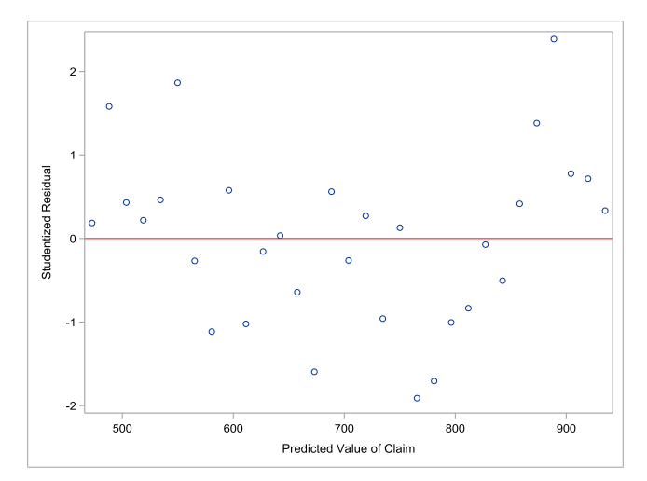
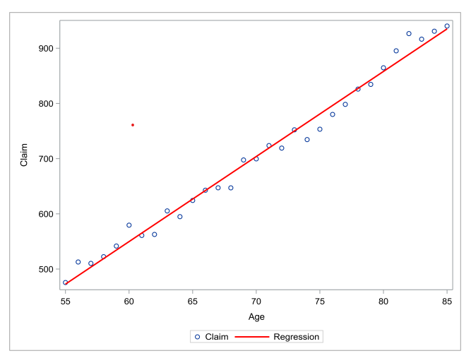

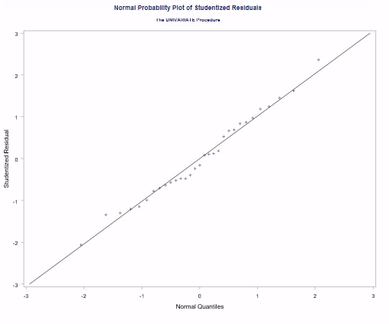
Table 3.1.2
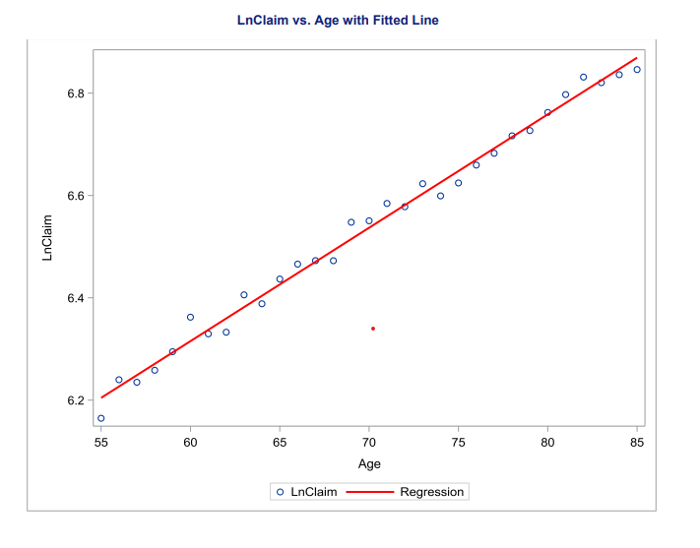

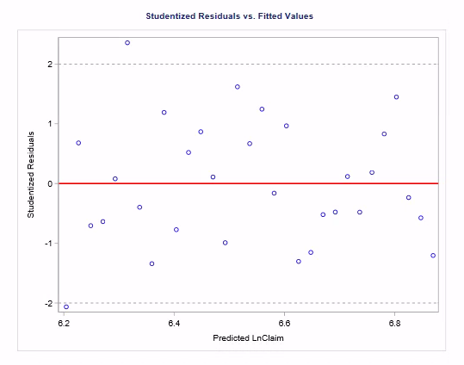
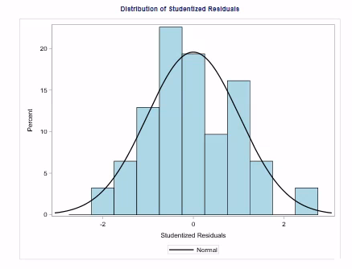

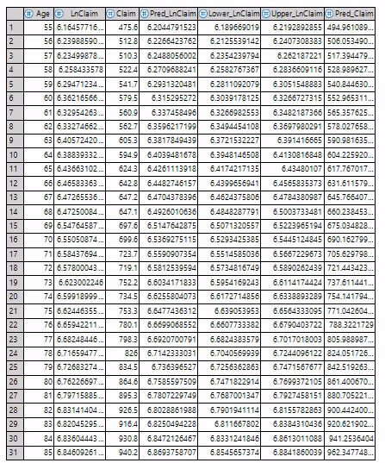
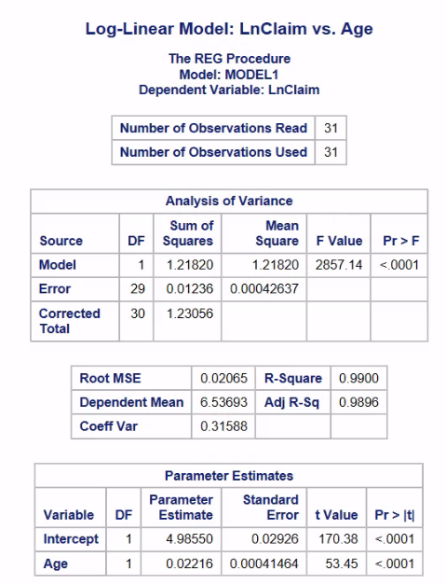
Table 3.1.3

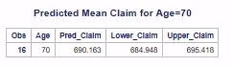

Table 4.1.1
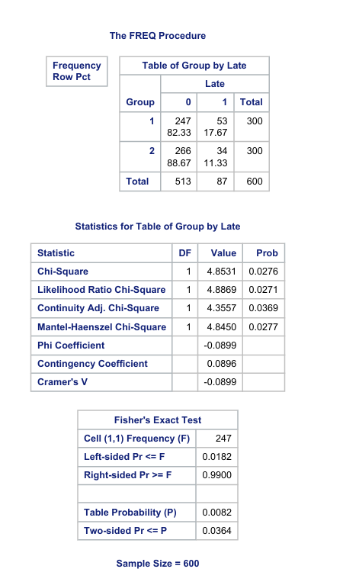

Table 4.1.2
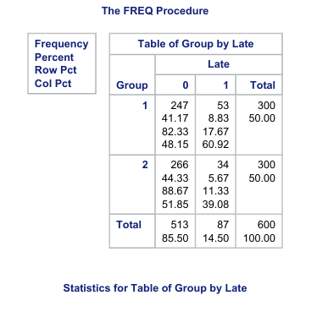
Table 4.1.3
